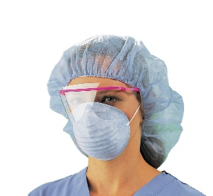
PPE Training for staff/LMCs

Drop-in sessions

An opportunity for staff and LMCs to refamiliarise themselves with use off of PPE as part of the planning for COVID – 19.

When | Where | Time
Monday 23rd | Lincoln Maternity – education room | 13.00 – 15.00hr
Tuesday 24th | NZCOM, 376 Manchester Street – come to main entrance | 10.00 – 12.30hr
Wednesday 25th | NZCOM, 376 Manchester Street – come to main entrance | 10.00 – 14.30hr
Thursday 26th | Rangiora Maternity | 12.00 – 15.00hr
Friday 27th | Rangiora Maternity | 9.30 – 12.00hr

Staff and LMCs are encouraged to complete the Covid-19 Infection Prevention learning package, particularly about putting on (donning) and taking off (doffing) PPE. This takes approximately 30 minutes to complete.

https://www.healthlearn.ac.nz/course/search.php?search=covid+

